**King Khalid University computer science department**

**DESIGN THINKING**

**_____________________________________________**

**Research in**

**What Role Does Cognition have**

**By**

**Student names here**

**For**

**Doctor name here**

**2023-2024**

**What is Design Thinking?**

* Design thinking is a creative problem-solving technique based on a set of abilities.
* The method has been around for decades, but it only gained popularity outside of the design industry after Tim Brown, CEO and president of design firm IDEO, published "Design Thinking" in the 2008 Harvard Business Review [subscription required].
* Since then, the design thinking method has been used to develop new goods and services, as well as to solve a wide range of challenges, from developing a business strategy for selling solar panels in Africa to running Airbnb.

**What are the processes of Design Thinking?**

There are five key steps in the design thinking process:

* Empathize, the first phase in design thinking is to observe with empathy.
* Define, process what you’ve learned from your audience; compile it into insights.
* Ideate, is a brain dump of ideas, and nothing is off limits.
* Prototype, could consist of a wall of Post-it Notes, a storyboard, a physical/digital item.
* Test, learn more about your possible solutions.
* One thing to keep in mind is that the process isn’t always linear:
  + any one of the five stages of the design thinking process could spark an idea or outcome that leads to repeating an earlier stage. For this reason, the design thinking approach is often referred to as a non-linear, iterative process.

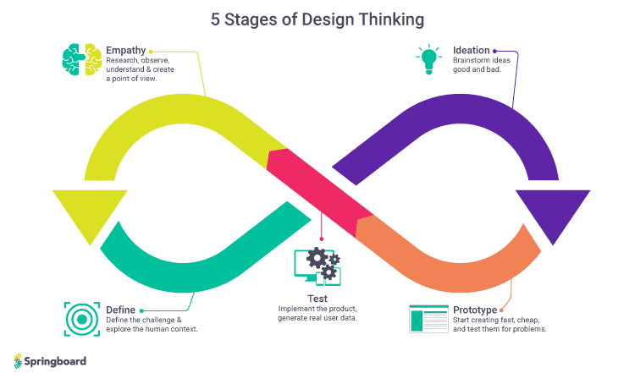

**How are we applying Design Thinking Framework?**

* Design thinking can also begin with a modest step—you don't have to become a UX designer to apply design thinking to your own job! You may like to concentrate on a single part of the design thinking process, such as getting to know your clients and making a conscious effort to be more empathy-driven on a daily basis. If you're having trouble gathering favorable customer reviews, for example, you may conduct user interviews to learn what your consumers are lacking.
* Design thinking workshops are another increasingly popular way to apply design thinking. A design thinking workshop will take you through the complete design thinking process in a short amount of time if you have a specific problem you want to solve, such as coming up with a new product idea or working out how to enhance staff retention. Design thinking seminars are also used to teach non-design professionals how to innovate and create innovative solutions, which is a necessary talent in any organization.

**What is cognition?**

* Cognition is described as the mental action or process of obtaining knowledge and understanding through thought, experience, and the senses.' At Cambridge Cognition, we define it as the mental processes involved in the acquisition and storage of information, as well as how that information is used to influence your behavior.
* It is in essence, the ability to perceive and react process, and understand, store, and retrieve information, make decisions and produce appropriate responses.

**What role does cognition have?**

* The cognitive of design thinking studies how our brain processes information. It is a field that draws from various areas, including neuroscience, psychology, sociology, artificial intelligence, and more.
* It looks at how we interpret information and makes sense of it. Understanding this process can help us to design better products and experiences that people find helpful and easy to use.

**How our brain processes information?**

* The cognitive psychology of design thinking studies how our brain processes information. It explores how we think and make decisions and how these processes can be improved through better design.
* The brain is a highly intricate organ that is made up of various distinct components, such as:
* The cerebrum (the outer layer)
* The limbic system (emotional center)
* Thalamus (receives signals from other parts of your body)

**How we interpret information and makes sense of it?**

* Designers have been using design thinking to solve problems for decades. It investigates how humans understand and make meaning of information. This approach is used by designers to tackle complex problems or to develop something new.
* Design thinking cognitive psychology investigates how human brain receives information, makes decisions based on that knowledge, remembers things, learns from experience, and so on.

**The cognitive psychology of design thinking is critical to understanding our brains and how they work to better goods and experiences.**

* Empathy, creativity, and cooperation are used in design thinking to solve challenges creatively by understanding users' needs at all stages of development, from conception through prototype.
* Designers use this process to overcome challenges by thinking differently about them; for example, instead of trying to solve a problem by adding more technology (which isn't always possible), designers may look at another angle, such as reducing manual labor required from employees who interact with customers on a regular basis, so they don't get tired out too quickly!

**Understanding this process can help us to design better product.**

* Design thinking is a process that helps you to understand how people think and what they need. It's about approaching problems differently by asking questions like:
* What do users want?
* What motivates them?
* How can we make their lives easier or better?

**Human Cognition and its effect on design**

* Language & Typography
  + Language and Typography of a product influences reading and comprehension. Inappropriate Language and typography often mislead users.
* Scanning
  + Usually, users do not get involved deeply on every website. They do not even read all the content. They just scan the pages. It depends on the type of websites and design of the products, our users follow certain scanning pattern like Z-Pattern, Zig-Zag Pattern and F-Pattern to scan the pages.
* Memory
  + It depends on user’s memory how they acquire knowledge, build concepts for new things, deal with information overload, and their working memory to accomplished task.
* Problem solving and decision making.
  + Users choose among different possibilities, build strategies, take decisions and solve the problems with help of their knowledge, previous experience and common sense.

**Conclusion:**

The cognitive psychology of design thinking is critical to understanding our brains and how they work to better goods and experiences. It's also a fascinating field that draws on several disciplines, including neuroscience, psychology, and sociology. We can create better designs that are more likely to be understood by consumers if we consider how people think about information and make sense of it something everyone should be aware of.